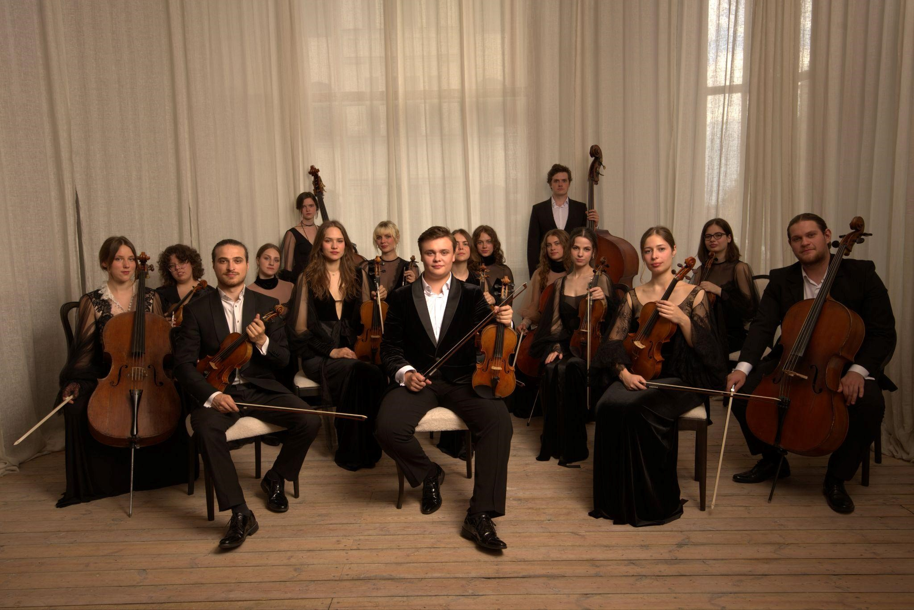

String chamber orchestra

Davinspiro Camerata

Davinspiro Camerata Chamber Orchestra was founded in Riga (Latvia) by violinist Daniil Bulayev who passions to music and believes in the power of music. Davinspiro Camerata Chamber Orchestra is Latvian most gifted musicians who live and breathe music. Davinspiro Camerata continuously keeps shaping its distinct sound and independent artistic identity. The orchestra is constantly on the move in search of the next musical horizon. Davinspiro Camerata musicians all commite to develop, get the highest-quality orchestral experiences, share a strong desire to continually deepen their engagement with audiences, share their passion to music.

During these first few years Davinspiro Camerata has already collaborated with such prominent artists as:

- conductor and violinist Andres Mustonen
- double bassist Grigory Kovalevsky
- cellist Mischa Maisky
- violinist Elīna Bukša
- cellist Guna Šnē
- pianist Agnese Egliņa
- percussionist Andrei Pushkarev
- mezzo soprano Luciana Mancini
- singer Daumants Kalniņš
- actor Daniel Bonilla-Torres

Davinspiro Camerata has performed in many concert halls:

- The Great Guild (Lielā ģilde)
- Latvian National Theatre (Latvijas Nacionālais teātris)
- Dzintari Concert Hall (Dzintaru koncertzāle)
- “Great Amber” Concert Hall (koncertzāle “Lielais Dzintars”)
- Sigulda Concert Hall “Baltais flīģelis” (Siguldas koncertzāle “Baltais flīģelis”)
- Concert Hall “Cēsis” (Vidzemes koncertzāle “Cēsis”)
- Viljandi Baptistikirik Concert Hall in Estonia
- Champs Hill concert venue in London

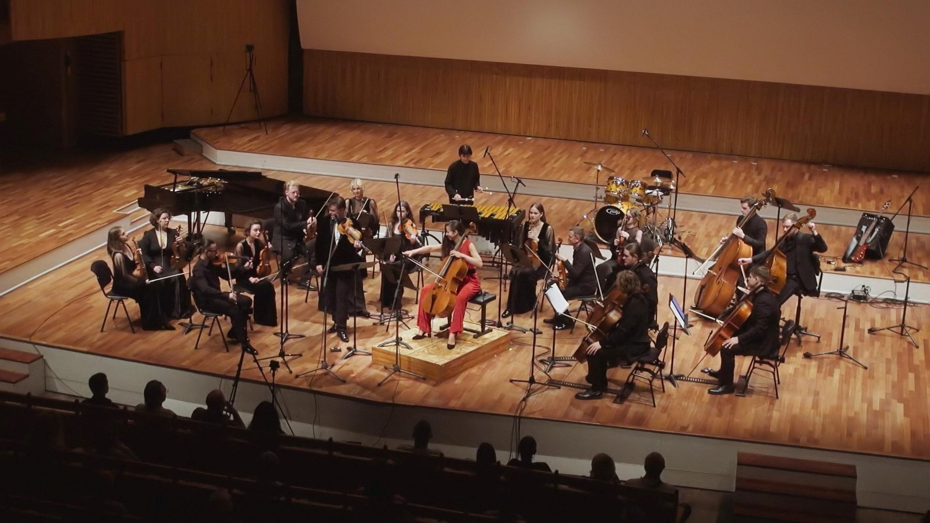
From concert Atdzimšana in Great Guild 21.06.2024

In 2022 Davinspiro Camerata recorded G. Enescu’s Octet in C dur with Champs Hill
Records label in London. The record will be published in early 2025. On October 10, 2024, Davinspiro Camerata performed the Octet in Champs Hill Music Room’s anniversary concert in London.

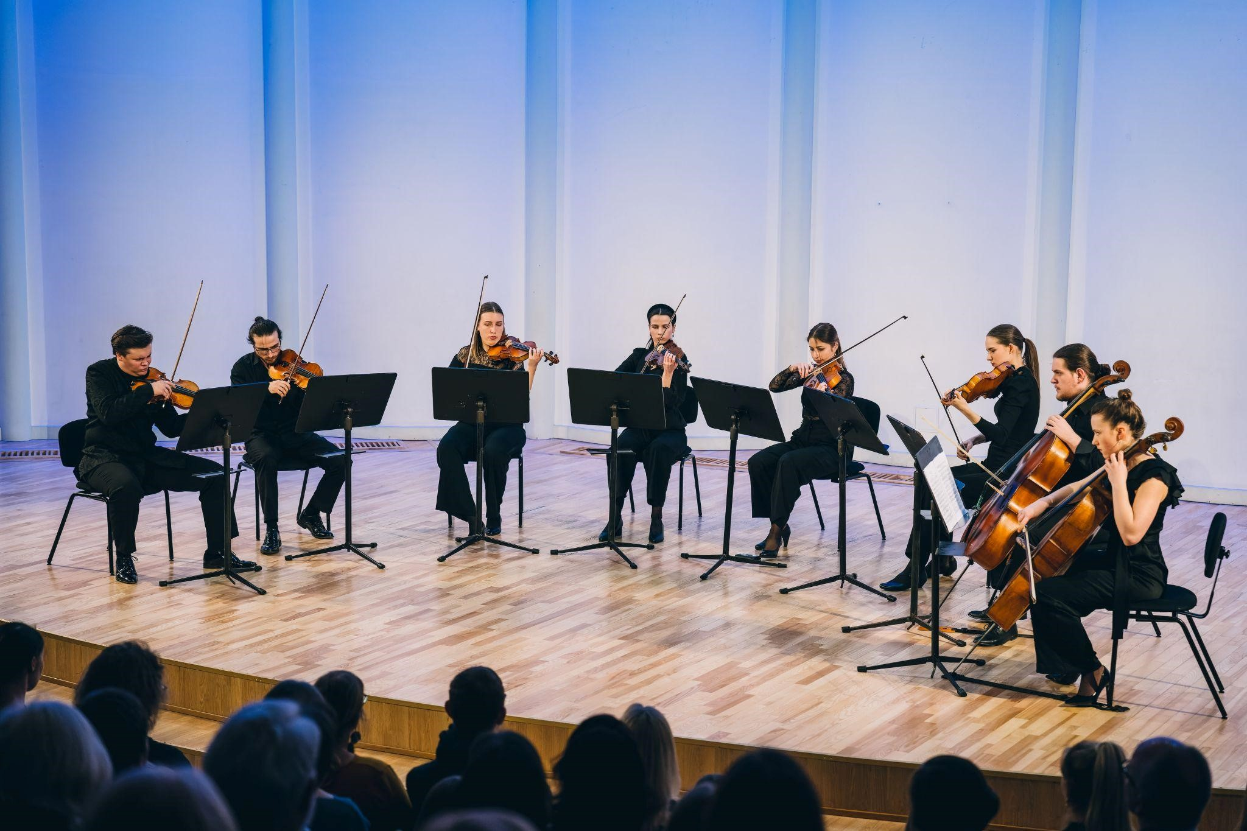
Performance of G. Enescu Octet in C dur at Concert Hall Baltais flīģelis

Video recordings of Davinspiro Camerata

Video Recordings of Davinspiro Camerata chamber orchestra You can find it on the orchestra's YouTube channel - Davinspiro Camerata chamber orchestra

Some direct links to the video:
- Dm.Shostakovich - Chamber symphony, op.110a

- G.Gershwin - The Man I Love

- G.Enescu - String octet

- A.Piazzolla - Operita “Maria de Buenos Aires” aria “Yo soy Maria”

Instagram: @davinspirocamerata

Contacts:
Daniil Bulayev
+371 26485773
dbulayev.management@gmail.com

